**Q-1 W.A.P. TO CREATE A CLASS CALLED EMPLYEE WHOSE DATA MEMBERS ARE EMPCODE , EMPNAME , EAGE , ESALARY. W.A.P. TO READ HIRE EMPLOYEE INFORMATION WHOSE AGE IS MORE THAN 40 OR SALARY IS 2500.**

**===================================================================**

**A-1 :-**

#include<iostream.h>

#include<conio.h>

class Emp

{

public :

int Ecode;

char Ename[20];

int Eage;

float Esal;

void getdata();

void putdata();

};

void Emp :: getdata()

{

cout<<"\n Enter employee code =>";

cin>>Ecode;

cout<<"\n Enter employee name =>";

cin>>Ename;

cout<<"\n Enter employee age =>";

cin>>Eage;

cout<<"\n Enter employee salary =>";

cin>>Esal;

}

void Emp :: putdata()

{

if(Eage>=40&&Esal>=25000)

{

cout<<"\n Employee code =>"<<Ecode;

cout<<"\n Employee name =>"<<Ename;

cout<<"\n Employee age =>"<<Eage;

cout<<"\n Employee salary =>"<<Esal;

}

}

void main()

{

int i;

clrscr();

Emp x[2];

for(i=0;i<2;i++)

{

x[i].getdata();

}

for(i=0;i<2;i++)

{

x[i].putdata();

}

getch();

}

**OUTPUT :-**

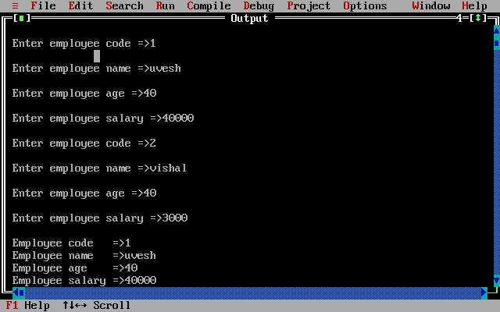

**Q-2 W.A.P. TO CREATE A CLASS CALLED ITEM WHICH HAS DATA MEMBERS ITEMCODE,PRICE AND COUNT.WE PERFORM DIFFERENT OPERATION SUCH AS ADDING ITEM,REMOVE ITEM,DISPLAY ITEM,DISPLAT TOTAL OF ITEM,PRICE AND DISPLAY THE DETAIL OF ITEM.**

**===================================================================**

**A-2 :-**

#include<iostream.h>

#include<conio.h>

class item

{

int itemcode[20];

float price[50];

int count;

public:

void ccount()

{

count=0;

}

void additem()

{

cout<<"\n Enter the item code =";

cin>>itemcode[count];

cout<<"\n Enter the item price =>";

cin>>price[count];

count = count + 1;

}

void removeitem()

{

int code;

cout<<"\n Enter the item code for remove =>";

cin>>code;

for(int i=0;i<count;i++)

{

if(itemcode[i]==code)

{

price[i] = 0;

}

}

}

void displaytotal()

{

int sum=0;

for(int i=0;i<count;i++)

{

sum = sum + price[i];

}

cout<<"\n Total price"<<sum;

}

void displayitem()

{

cout<<"\nItemcode\tPrice";

for(int i=0;i<count;i++)

{

if(price[i]!=0)

{

cout<<"\n"<<itemcode[i]<<"\t\t"<<price[i];

}

}

}

};

void main()

{

int ch;

clrscr();

item it;

it.ccount();

do

{

cout<<"\n 1. Add item";

cout<<"\n 2. Remove item";

cout<<"\n 3. Displaytotal";

cout<<"\n 4. Displayitem";

cout<<"\n 5. EXIT ";

cout<<"\n Enter your choice =";

cin>>ch;

switch(ch)

{

case 1 :

it.additem();

break;

case 2 :

it.removeitem();

break;

case 3 :

it.displaytotal();

break;

case 4 :

it.displayitem();

break;

case 5 :

break;

default :

cout<<"\n Invalid choice";

break;

}

}while(ch!=5);

getch();

}

**OUTPUT :-**

1. **Add Item**

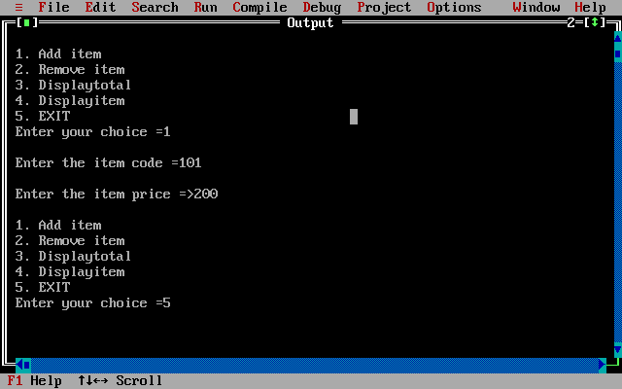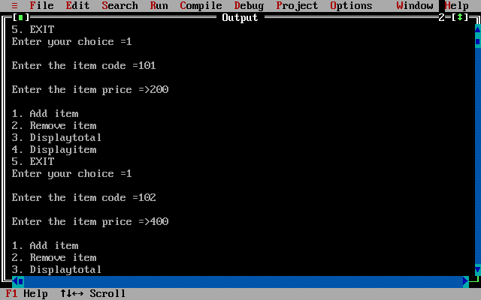

**2.Remove Item**

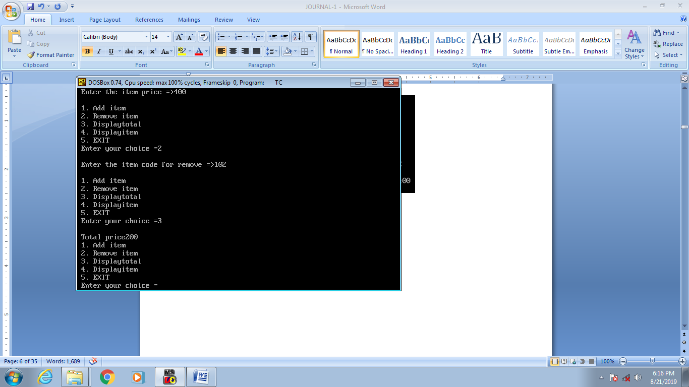

**3.Display Total**

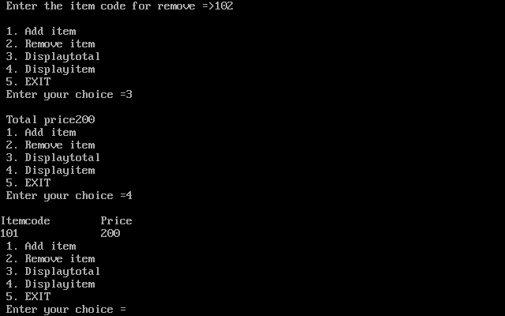

**4.Display Item**



**Q-3 W.A.P. TO TO FIND PRIME NUMBER BETWEEN ADDING TWO NUMBER WHICH IS INPUTED BY USER.**

**==================================================================**

**A-3 :-**

#include<iostream.h>

#include<conio.h>

class prime

{

public :

int start,end,i,j,a;

void getdata()

{

cout<<"\n Enter Starting value =>";

cin>>start;

cout<<"\n Enter Ending Value =>";

cin>>end;

}

void calculate()

{

cout<<"\n Prime Number between "<<start<<"&"<<end<<" =>"<<endl;

for(i=start;i<end;i++)

{

a=0;

for(j=2;j<i;j++)

{

if(i%j==0)

{

a=1;

}

}

if(a==0)

{

cout<<i<<endl;

}

}

}

};

void main()

{

clrscr();

prime p;

p.getdata();

p.calculate();

getch();

}

**OUTPUT :-**

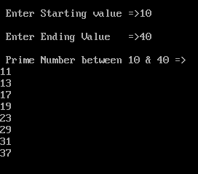

**Q-4 W.A.P.TO FIND PALIDROME NUMBER OR STRING WHICH IS IPUTED BY USER.**

**===================================================================**

**A-4 :-**

#include<iostream.h>

#include<conio.h>

#include<string.h>

class palindrome

{

char a[15],b[15];

public :

void get()

{

cout<<"\n Enter any value =>";

cin>>a;

}

void compare()

{

strcpy(b,a);

strrev(b);

if(strcmp(a,b)==0)

{

cout<<" Is Palindrome "<<a;

}

else

{

cout<<" Is Not Palindrome "<<a;

}

}

};

void main()

{

clrscr();

palindrome p;

p.get();

p.compare();

getch();

}

**OUTPUT :-**



**Q-5 W.A.P. TO PERFORM THE ADDITION OF TIME IN HOUR AND MINTUES FROMAT BY THE USE OF OBJECT FUNCTION ARGUMENT.**

**===================================================================**

**A-5 :-**

#include<iostream.h>

#include<conio.h>

class person

{

int h;

int m;

public :

void assign(int n,int s);

void add(person);

};

void person :: assign(int n,int s)

{

h=n;

m=s;

}

void person :: add(person p)

{

int min,hr;

hr=h+p.h;

min=m+p.m;

if(min%60!=0)

{

hr=hr+(min/60);

min=min%60;

}

cout<<"\n HOUR =>"<<hr;

cout<<"\n MIN =>"<<min;

}

void main()

{

clrscr();

person x,y;

x.assign(3,20);

y.assign(2,30);

x.add(y);

getch();

}

**OUTPUT :-**



**Q-6 W.A.P. FOR SIMPLE INTEREST USING INLINE FUNCTION.**

**===================================================================**

**A-6 :-**

#include<iostream.h>

#include<conio.h>

inline float si(float A,float B,float C)

{

return(A*B*C/100);

}

void main()

{

float p,r,n;

clrscr();

cout<<"\n Enter the Principal Amount =>";

cin>>p;

cout<<"\n Enter the Rate of Intereset =>";

cin>>r;

cout<<"\n Enter the Time Period =>";

cin>>n;

cout<<si(p,r,n);

getch();

}

**OUTPUT :-**

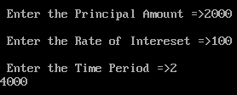

**Q-7 W.A.P. TO CREATE A CLASS CALLED MEMBER WHICH HAS TWO INTEGER VALUES NO.1,NO.2, AS DATA MEMBER WRITE A CODE THE FUNCTION GETDATA AND PUTDATA AND METHOD CALLED SUM WHICH ADD THE TWO OBJECTS FOR EXAMPLE NO.1 WILL BE ADDED TO NO.2 OF OTHER OBJECT.**

**===================================================================**

**A-7 :-**

#include<iostream.h>

#include<conio.h>

class member

{

int n;

public:

void get()

{

cout<<"\n Enter No =>";

cin>>n;

}

void put()

{

cout<<"\n No is =>"<<n;

}

void sum(member a,member b)

{

cout<<"\n\n\t Sumation is =>"<<a.n+b.n;

}

};

void main()

{

clrscr();

member x,y,z;

x.get();

y.get();

x.put();

y.put();

z.sum(x,y);

getch();

}

**OUTPUT :-**

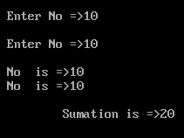

**Q-8 W.A.P. TO GENRATE MARKSHEET[STUDENT] USING CLASS.**

**===================================================================**

**A-8 :-**

#include<iostream.h>

#include<conio.h>

class student

{

private:

int rno;

char n[30],city[30];

public:

void get();

void put();

};

void student :: get()

{

cout<<"\n Enter Student Roll No ==>";

cin>>rno;

cout<<"\n Enter Student Name ==>";

cin>>n;

cout<<"\n Enter Student City ==>";

cin>>city;

}

void student :: put()

{

cout<<"_______________________________________________________________";

cout<<"\n|Rollno:-"<<rno<<" \t\t |Name:-"<<n<<" \t\t |City:-"<<city;

// cout<<"\n "<<rno<<"| \t\t "<<n<<"| \t\t "<<city<<"|\n";

cout<<"\n--------------------------------------------------------------";

}

class test : public student

{

protected:

float rd,c,ds;

public:

void getm();

void putm();

};

void test :: getm()

{

cout<<"\n Enter RDBMS Marks ==>";

cin>>rd;

cout<<"\n Enter C + + Marks ==>";

cin>>c;

cout<<"\n Enter D.S. Marks ==>";

cin>>ds;

}

void test :: putm()

{

cout<<"\n Subjects | marks | ";

cout<<"\n RDBMS ==> | "<<rd<<" |";

cout<<"\n C + + ==> | "<<c<<" |";

cout<<"\n D.S. ==> | "<<ds<<" |";

}

class sports : public test

{

protected:

float sc;

public:

void getsc();

void putsc();

};

void sports :: getsc()

{

cout<<"\n Enter Sports Score ==>";

cin>>sc;

}

void sports :: putsc()

{

cout<<"\n Sports ==> | "<<sc<<" |";

}

class result : public sports

{

public:

void show();

};

void result :: show()

{

int tot;

float p;

put();

putm();

putsc();

tot=rd+c+ds+sc;

p=tot*100/400;

cout<<"\n ----------";

cout<<"\n \t Total Marks ==>| "<<tot<<" |";

cout<<"\n \t Total Percentage ==>| "<<p;

if(p>=70)

{

cout<<"\n\t CLASS\t ==> Distinction !!!";

}

else if(p>=60)

{

cout<<"\n\t CLASS\t ==> First Class !!!";

}

else if(p>=50)

{

cout<<"\n\t CLASS\t ==> Second Class !!!";

}

else if(p>=35)

{

cout<<"\n\t CLASS\t ==>Pass !!!";

}

else

{

cout<<"\n\t CLASS\t ==> Fail !!!";

}

}

void main()

{

clrscr();

result a;

a.get();

a.getm();

a.getsc();

cout<<"\n\t\t\t MARKSHEET !!!\n";

a.show();

getch();

}

**OUTPUT :-**

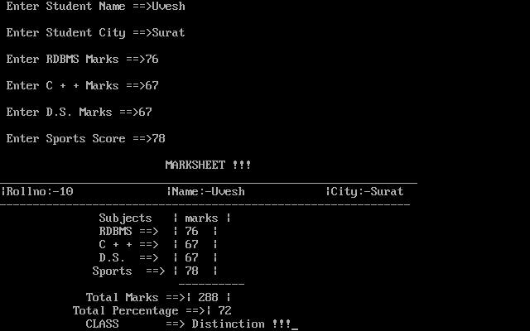

**Q-9 W.A.P. FOR MULTIPLE AND MULTILEVEL INHERITANCE WITH PROPER EXAMPlE.**

**===================================================================**

**A-9 :-**

#include<iostream.h>

#include<conio.h>

class student

{

private:

int rno;

char n[30],city[30];

public:

void get();

void put();

};

void student :: get()

{

cout<<"\n Enter Student Roll No =>";

cin>>rno;

cout<<"\n Enter Student Name =>";

cin>>n;

cout<<"\n Enter Student City =>";

cin>>city;

}

void student :: put()

{

cout<<"_______________________________________________________________";

cout<<"\n|Rollno:-"<<rno<<" \t\t |Name:-"<<n<<" \t\t |City:-"<<city;

// cout<<"\n "<<rno<<"| \t\t "<<n<<"| \t\t "<<city<<"|\n";

cout<<"\n--------------------------------------------------------------";

}

class test : public student

{

protected:

float rd,c,ds;

public:

void getm();

void putm();

};

void test :: getm()

{

cout<<"\n Enter RDBMS Marks =>";

cin>>rd;

cout<<"\n Enter C + + Marks =>";

cin>>c;

cout<<"\n Enter D.S. Marks =>";

cin>>ds;

}

void test :: putm()

{ cout<<"\n Subjects | marks | ";

cout<<"\n RDBMS => | "<<rd<<" |";

cout<<"\n C + + => | "<<c<<" |";

cout<<"\n D.S. => | "<<ds<<" |";

}

class sports

{

protected:

float sc;

public:

void getsc();

void putsc();

};

void sports :: getsc()

{

cout<<"\n Enter Sports Score =>";

cin>>sc;

}

void sports :: putsc()

{

cout<<"\n Sports => | "<<sc<<" |";

}

class result : public test , public sports

{

public:

void show();

};

void result :: show()

{

int tot;

float p;

put();

putm();

putsc();

tot=rd+c+ds+sc;

p=tot*100/400;

cout<<"\n ----------";

cout<<"\n \t Total Marks =>| "<<tot<<" |";

cout<<"\n \t Total Percentage =>| "<<p;

if(p>=70)

cout<<"\n\t CLASS\t => Distinction !!!";

else if(p>=60)

cout<<"\n\t CLASS\t => First Class !!!";

else if(p>=50)

cout<<"\n\t CLASS\t => Second Class !!!";

else if(p>=35)

cout<<"\n\t CLASS\t =>Pass !!!";

else

cout<<"\n\t CLASS\t => Fail !!!";

}

void main()

{

clrscr();

result a;

a.get();

a.getm();

a.getsc();

cout<<"\n\t\t\t MARKSHEET \n";

a.show();

getch();

}

**OUTPUT :-**



**Q-10 W.A.P. THAT DISPLAY A MENU WITH ADDITION , SUBTRACTION , MULTIPLICATION , DIVISION. IMPLIMENT THIS OPERATION IN CLASS USE THE SPRATE FUNCTION FOR CALCULATION.INCLUDE A FUNCTION TO CHECK THAT THE SECOND VALUE IS NOT GREATER THAN THE FIRST VALUE.**

**===================================================================**

**A-10 :-**

#include<iostream.h>

#include<conio.h >

class calc

{

int a,b,c;

public :

void add(float a,float b);

void sub(float a,float b);

void mul(float a,float b);

void div(float a,float b);

};

typedef calc c;

void c :: add(float a,float b)

{

float c;

c=a+b;

cout<<"\n Result of Addition =>"<<c;

}

void c :: sub(float a,float b)

{

float c;

c=a-b;

cout<<"\n Result of Subtraction =>"<<c;

}

void c :: mul(float a,float b)

{

float c;

c=a*b;

cout<<"\n Result of Multipliction =>"<<c;

}

void c :: div(float a,float b)

{

float c;

c=a/b;

cout<<"\n Result of Division =>"<<c;

}

void main()

{

int ch;

clrscr();

c x;

float a,b;

cout<<"\n Enter value of a =>";

cin>>a;

cout<<"\n Enter value of b =>";

cin>>b;

if(a<b)

{

cout<<"\n Enter value of a =>";

cin>>a;

cout<<"\n Enter value of b =>";

cin>>b;

}

if(a>b)

{

cout<<endl<<" MENU ";

do

{

cout<<"\n 1. ADDITION =>";

cout<<"\n 2. SUBTRACTION =>";

cout<<"\n 3. MULTIPLCATIO =>";

cout<<"\n 4. DIVISION => ";

cout<<"\n 5. EXIT ";

cout<<"\n Enter your choice =>";

cin>>ch;

switch(ch)

{

case 1 :

x.add(a,b);

break;

case 2 :

x.sub(a,b);

break;

case 3 :

x.mul(a,b);

break;

case 4 :

x.div(a,b);

break;

case 5 :

break;

default :

cout<<"\n INVALID CHOICE ";

break;

}

}while(ch!=5);

}

else

{

cout<<"\n Value of a is Smallerthan b" ;

}

getch();

}

**OUTPUT :-**

**1. ADDITION**

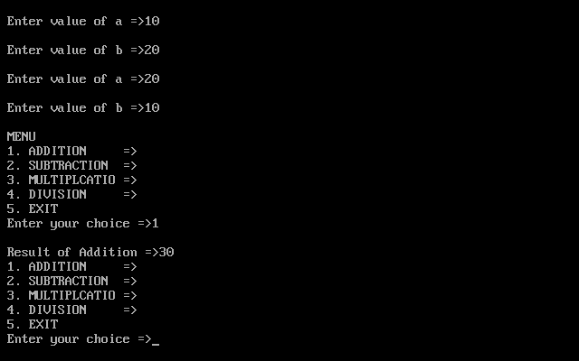

**2. SUBTRACTION**

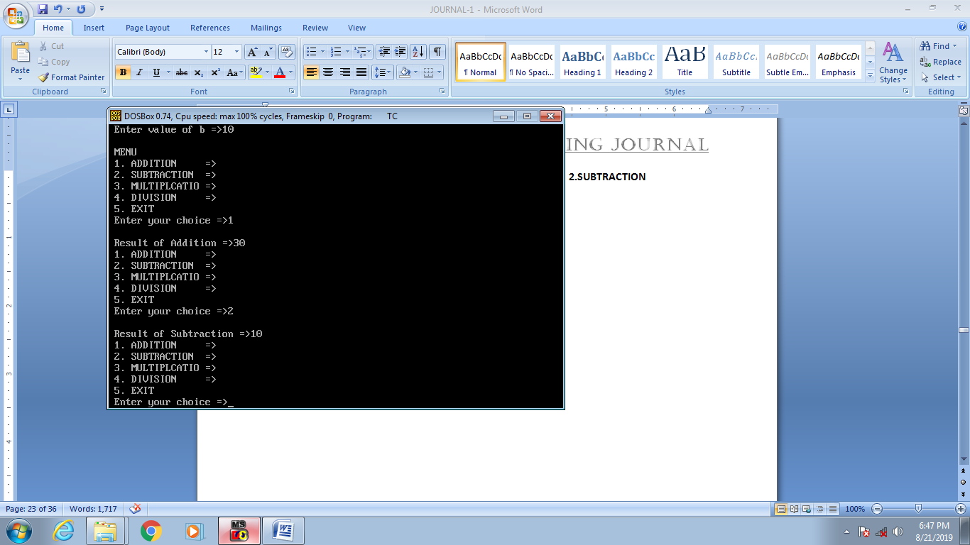

**3. MULTIPLICATION**

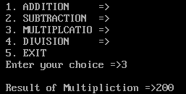

**4. DIVISION**

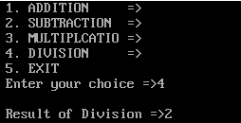

**INVALID CHOICE**

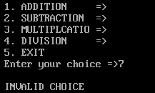

**Q-11 W.A.P. FOR STATIC DATA MEMBER FUNCTION.**

**===================================================================**

**A-11 :-**

#include<iostream.h>

#include<conio.h>

class item

{

static int count;

int no;

public :

void getdata(int a)

{

no=a;

count++;

}

void getcount(void)

{

cout<<"\n COUNT =>"<<count;

}

};

int item :: count;

void main()

{

clrscr();

cout<<"\n Before reading data ";

item a,b,c;

a.getcount();

b.getcount();

c.getcount();

a.getdata(100);

b.getdata(300);

c.getdata(300);

cout<<"\n After reading data ";

a.getcount();

b.getcount();

c.getcount();

getch();

}

**OUTPUT :-**

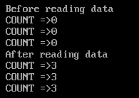

**Q-12 W.A.P. TO CREATE A CLASS CALLED POUND THAT SOTERS DATA IN POUND AND CLASS RUPEES THAT STORE DATA IN RUPEES.PERFORM THE OPERATION AND TO CARRY OUT OF THIS VALUE.**

**===================================================================**

**A-12 :-**

#include<iostream.h>

#include<conio.h>

class pound

{

float p;

public :

void getdata()

{

cout<<"\n Enter The Pound Amount =>";

cin>>p;

}

void convert()

{

cout<<"\n Converted Amount is (approx 90):RS."<<p*90.0;

}

};

class rupees

{

float rs;

public :

void getdata()

{

cout<<"\n Enter Rupees Amount =>";

cin>>rs;

}

void convert()

{

cout<<"\n Converted Amount is (approx 90):$."<<rs/90.0;

}

};

void main()

{

clrscr();

pound po;

rupees ru;

int ch;

do

{

cout<<"\n\n Conversion : \n 1.POUND TO RUPEES \n 2.RUPEES TO POUND \n 3.EXIT ";

cout<<"\n Enter the Chocie =>";

cin>>ch;

switch(ch)

{

case 1 : po.getdata();

po.convert();

break;

case 2 : ru.getdata();

ru.convert();

break;

case 3 : break;

default : cout<<"\n INVALID CHOCIE ";

}

}while(ch!=3);

getch();

}

**OUTPUT :-**

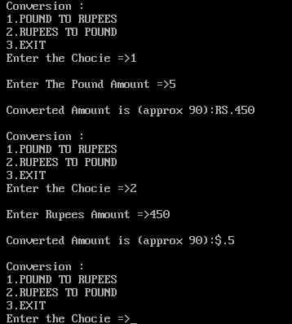

**Q-13 W.A.P. FOR MULTIPLE INHERITANCE WITH PROPER EXAMPLE.**

**===================================================================**

**A-13 :-**

#include<iostream.h>

#include<conio.h>

class alpha

{

int x;

public :

alpha(int i)

{

x=i;

cout<<"\n Constructor alpha intialized ";

}

void show_x(void)

{

cout<<"\n X ="<<x;

}

};

class beta

{

float y;

public :

beta(float j)

{

y=j;

cout<<"\n Consturctor beta is intialized ";

}

void show_y(void)

{

cout<<"\n Y = "<<y;

}

};

class gamma : public beta,public alpha

{

int m,n;

public :

gamma(int a,float b,int c,int d):alpha(a),beta(b)

{

m=c;

n=d;

cout<<"\n Constructor gamma is intialized ";

}

void show_mn(void)

{

cout<<"\n M = "<<m;

cout<<"\n N = "<<n;

}

};

void main()

{

clrscr();

gamma g(5,10.75,13,50);

// cout<<"\n endl ";

g.show_x();

g.show_y();

g.show_mn();

getch();

}

**OUTPUT :-**

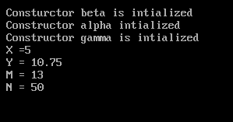

**Q-14 W.A.P. THAT CONSIST OF CLASSES TIME12 AND TIME24 THE FIRST MAINTANANCE TIME BASED ON 12 HOUR BASED AND WHERE AS OTHER MAINTANANCE IS ON 24 HOUR BASED.PROVIDE CONVERSION FUNCTION TO CARRY OUT THE CONVERSION FROM OBJECT OF ONE TYPE TO ANOTHER.**

**===================================================================**

**A-14 :-**

#include<iostream.h>

#include<conio.h>

class time24

{

public :

int h,m,mer;

void gettime()

{

cout<<"\n Enter hours =>";

cin>>h;

cout<<"\n Enter minutes =>";

cin>>m;

}

void showtime(int h,int m,char mer)

{

cout<<"\n\n";

if(mer!=0)

{

h=h+12;

}

if(h<=9)

{

cout<<"0"<<h<<":";

}

else

{

cout<<h<<":";

}

if(m<=9)

{

cout<<"0"<<"m";

}

else

{

cout<<m;

}

}

};

class time12

{

public :

int h,m,mer;

void gettime()

{

cout<<"\n Enter houres(12 hour format)=>";

cin>>h;

cout<<"\n Enter minutes=>";

cin>>m;

cout<<"\n Enter meridian 0 for AM \t\t 1 for PM ";

cin>>mer;

}

void showtime(int h,int m,char mer)

{

int temp;

cout<<"\n\n";

if(h>12)

{

temp=1;

h=h-12;

}

else

{

temp=0;

}

if(h<=9)

{

cout<<"0"<<h<<":";

}

else

{

cout<<h<<":";

}

if(m<9)

{

cout<<"0"<<m;

}

else

{

cout<<m;

}

if(temp==0)

{

cout<<"AM";

}

else

{

cout<<"PM";

}

}

};

void main()

{

int ch;

clrscr();

time12 t12;

time24 t24;

do

{

cout<<"\n\n 1.Enter data in 12 hour format =>";

cout<<"\n\n 2.Enter data in 24 hour format =>";

cout<<"\n\n 3.Exit";

cout<<"\n\n Enter your choice =>";

cin>>ch;

switch(ch)

{

case 1 :

t12.gettime();

t24.showtime(t12.h,t12.m,t12.mer);

break;

case 2 :

t24.gettime();

t12.showtime(t24.h,t24.m,t24.mer);

break;

case 3 :

break;

default :

cout<<"\n Invalid choice";

}

}while(ch!=3);

getch();

}

**OUTPUT :-**

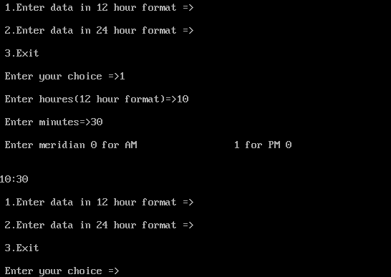

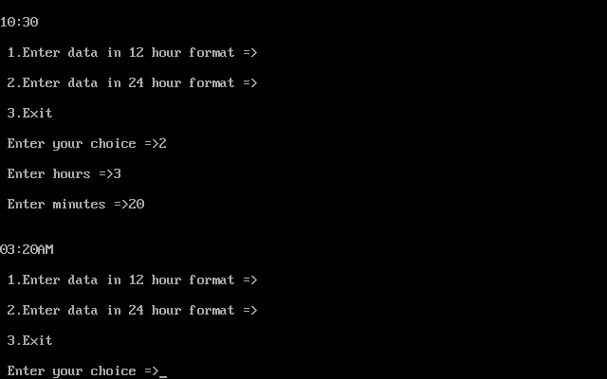

**Q-15 W.A.P. FOR MULTIPLE INHERITANCE DEFINE A CLASS PUBLISHER THAT STOERS THE NAME OF THE TITAL AND ANOTHER CLASS FOR SALE DETAIL WHICH INHERITANCE BOTH THE CLASS BOTH THE PUBLISHER AND DETAIL DEFINE FUNCTION IN THE APPROPRIATE TO GET AND PRINT THE DETAIL.**

**===================================================================**

**A-15 :-**

#include<iostream.h>

#include<conio.h>

class publisher

{

public :

char title[20];

char author[20];

};

class sales

{

public :

int n;

int price;

};

class book :public publisher,public sales

{

public :

void getdata()

{

cout<<"\n Enter The Title =>";

cin>>title;

cout<<"\n Enter The Auther =>";

cin>>author;

cout<<"\n Enter The Number of Book sold =>";

cin>>n;

cout<<"\n Enter The Price of Book =>";

cin>>price;

}

void putdata()

{

cout<<"\n Name of The Publisher Title =>"<<title;

cout<<"\n Name of The Author =>"<<author;

cout<<"\n Total of Book Price Sold =>"<<n*price;

}

};

void main()

{

clrscr();

book bk;

bk.getdata();

bk.putdata();

getch();

}

**OUTPUT :-**

